THE BOOK COVER MAKING

INTRODUCTION:

1.1 OVERVIEW:

A book cover has three mandatory parts: the front cover and the back cover, connected by the spine. A paperback book's pages are glued together with a paper cover and then cut to size. A hardback book's pages are sewn or glued into a “case” made of cardboard which is then covered with cloth or paper.

1.2 PURPOSE:

The purpose of book cover design is to draw the attention of your potential readers away from all those other tomes and novellas and sell them on the idea that your page-turner is the next book they need on their nightstand.

2. PROBLEM DEFINITION& DESIGN THINKING

2.1 EMPATHY MAP

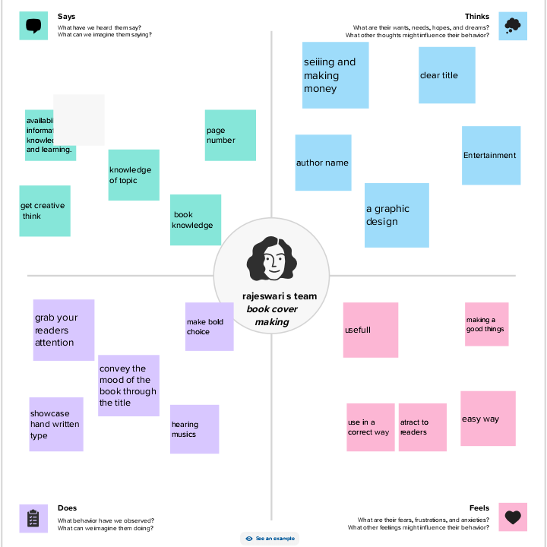

2.2 IDEATION & BRAINSTORMING MAP

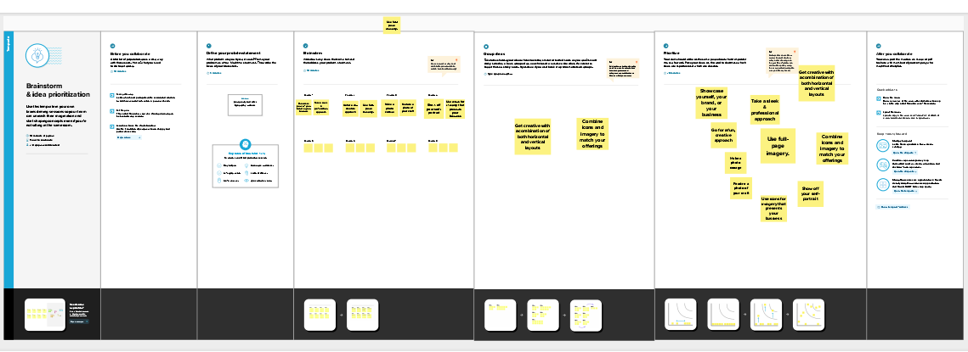

3.RESULT







4. ADVANTAGES OF BOOK COVER MAKING:

A well-designed cover can **make a book stand out in a crowded marketplace, and can help to establish an author's brand**. A book's cover and its content should be inextricably linked. A well-designed cover can communicate the book's content and tone, and can help to attract the right readers.

4.1 DISADVANTAGES OF BOOK COVER MAKING:

**Too many things on the cover become too hard to understand**. It is easy to lose structure, hierarchy, and cover your best design elements with too many things. Never cram too many visual symbols from the story. Don't include every important person, gun, cityscape, a religious symbol, etc.

5. APPLICATIONS:

A book cover has three mandatory parts: the front cover and the back cover, connected by the spine. A paperback book's pages are glued together with a paper cover and then cut to size. A hardback book's pages are sewn or glued into a “case” made of cardboard which is then covered with cloth or paper.

6. CONCLUSION:

**a well-designed book cover has the power to grab reader attention, convey the book's theme and content, and ultimately drive sales**.

7. FUTURE SCOPE:

* Book covers should give the readers a sneak peek of what's to come. ...
* Book covers should let readers know the book's genre. ...
* Book covers should introduce your protagonist. ...
* Book covers should set the right tone. ...
* Book covers should follow the rules of design in a way that makes sense for your genre.

/